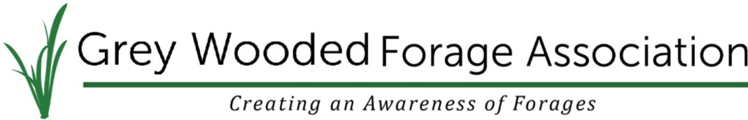
Box 1448, 5039-45 Street, Rocky Mountain House, Alberta T4T 1B1
403-844-2645 | gwfa3@telus.net | greywoodedforageassociation.com

Corporate Membership Application Form 2018

Date:__________________

Member Benefits:
- Digital Copy of the Blade for your own use and distribution
- Recognition on our website as a supporter of GWFA
- One free Farm Membership for you to give away as you choose
- Certificate of recognition will be given to you to display in your business

New Renewal

Company Name________________________________________________________

Contact Name_________________________________________________________

Address: _____________________________________________________________

City, Prov: ____________________________________________________________

Postal Code: __________________ Email: _______________________________

Corporate Memberships are $100.00 and are valid for the calendar year (Jan-Dec).

For inquiries please contact Ginette Boucher with the Grey Wooded Forage Association at
403-844-2645 or gwfa3@telus.net

