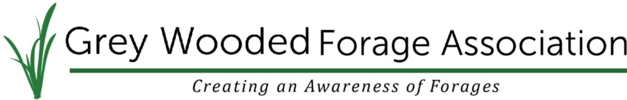
Corporate Sponsor packages

Platinum Sponsor: $2500.00
Platinum level corporate sponsors will have permanent recognition within our organization for one full calendar year. A full-page ad in The Blade publication will be available each month. A link to your website, company name/logo and up to three advertisements per month will be included in our digital mailout of GWFA happenings. You will also be recognized at our GWFA seminars, schools, tours, events and projects using your company name/logo. You are invited to be a guest speak at two events of your choice within the sponsorship year. Your company name/logo and links to your website and/or social media page will be on our website and Facebook page. You are invited to provide an article to be published in The Blade each month. Two representatives of your company are invited to attend all GWFA events free of charge and set up a booth with any materials you wish (event logistics allowing).

Gold Sponsor: $1500.00
Gold level corporate sponsors receive continuous recognition in our newsletters, as well as recognition at our GWFA seminars, schools, tours, events and projects using your company name/logo for one full calendar year. Gold sponsors will get a half page ad in the monthly Blade. Your company name/logo will be on our website and Facebook page as well as any links to your website. Gold sponsors are invited to provide an article for The Blade each month. One representative is invited to attend all GWFA events free of charge and set up a booth with any handout materials you wish (event logistics allowing).

Silver Sponsor: $1000
Silver level corporate sponsors receive continuous recognition in our newsletters, on our website as well as recognition at our GWFA seminars, schools, tours, events and projects using your company name/logo. Silver sponsors will receive a quarter page ad in the monthly Blade and are invited to provide an article for The Blade each month.

Friends of the Grey Wooded Forage Association: By Donation
Friends of the GWFA will be recognized at events, seminars, schools, and tours.

Corporate Sponsor Requirements: Corporate sponsors shall consist of companies, partnerships or corporations interested in supporting the values of our organization. We value our agricultural land, our farmers and ranchers in supporting them with economical and environmental sustainable management practices.

* Included in the Platinum and Gold Sponsorship packages is an annual membership with a printed copy of our publication. Additional copies can be delivered to you upon request.
Box 1448, 5039-45 Street, Rocky Mountain House, Alberta T4T 1B1
Phone: 403-844-2645, Email: gwfa3@telus.net Website: greywoodedforageassociation.com

Corporate Sponsor Application & Renewal Form 2018/2019

Company Name________________________________________________________

Contact Name_________________________________________________________

Address: _____________________________________________________________

City, Prov: ____________________________________________________________

Postal Code: __________________ Email: _______________________________

*Annual sponsors are from the date the sponsor is in effect and are valid for 365 days

Corporate Sponsor level (please circle one) Platinum Gold Silver

Sponsor Amount enclosed: _______________________

Date__________________________________________

Signature______________________________________

Privacy Act:

______________ Initial here if you agree to share your logo and contact information with the GWFA membership through the newsletter, and on the website or at GWFA event throughout the year

For inquiries please contact Ginette Boucher at the Grey Wooded Forage Association at 403-844-2645 or by email at gwfa3@telus.net

